**Any Photo of a Flat Horizon   
Taken from the Surface  
 Proves Nothing**

Photos of a flat horizon, taken from the surface are bad evidence of Flat Earth and Round Earth theories. They prove nothing. But some examples, such as this are *bad examples of bad evidence.*

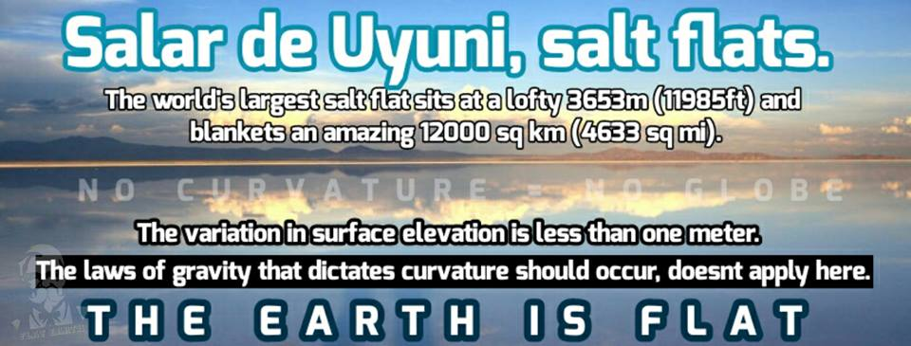

The right image is an exact copy of the left image compressed horizontally. It’s not even a flat horizon. Dismiss it.

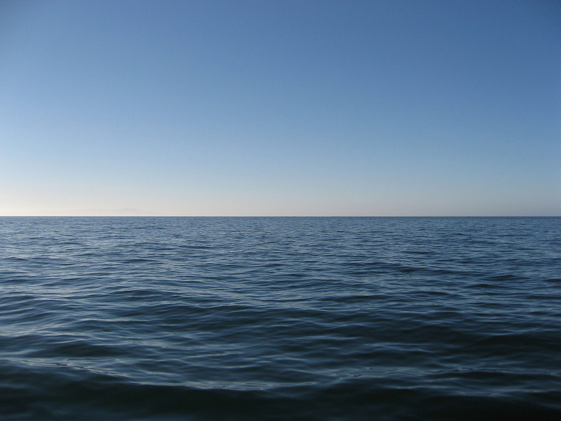

So, let’s start with a GOOD example of bad evidence. [This beautifully flat horizon](http://aplacetospoutmyanger.blogspot.com/2015/07/the-earth-is-flat-strong-delusion-is.html) is taken from just above the surface. Let’s say the photographer is in a boat, 10 feet above sea level. Let’s also say they have a rectilinear 50mm lens, which is as close to the human eye as can be done in photography. This photo passes the compression test.

But, is it even possible to show curvature from the surface? **No, it’s impossible**, and this can be proven by anyone with basic math, provided to us conveniently in the form of theory-agnostic online calculators.

Let’s say one degree of curvature is barely enough to prove a spherical earth. Five degrees would be a slam dunk, but let’s assume one degree is enough. What is the length of a 1-degree arc, assuming an [earth radius of 67,371 km](https://en.wikipedia.org/wiki/Earth_radius). This is conveniently provided by this [handymath.com calculator](http://www.handymath.com/cgi-bin/arc18.cgi?submit=Entry).





Curved Horizon Length = 3858km = 731 miles. Our perfect 50mm rectilinear lens has a [horizontal field of view](https://en.m.wikipedia.org/wiki/Angle_of_view) of 39.6 degrees. We’ll use half the field of view (19.8 deg and 365 mi) to form a right triangle, and then [calculate our distance from the arc](https://www.pagetutor.com/trigcalc/trig.html). Distance = 1014 miles.



**This is a problem.**  We must be over a thousand miles away to see a barely-sufficient 1 degree arc of curvature. Maybe on a flat earth one can see 1000 miles, [but on a round earth](https://dizzib.github.io/earth/curve-calc/?d0=30&h0=10&unit=imperial), the actual horizon is about four miles.



**Conclusion**: do not use photos of a horizon 4 miles away to support either theory.

